A robot is located at the top-left corner of a m x n grid (marked 'Start' in the diagram below).

The robot can only move either down or right at any point in time. The robot is trying to reach the bottom-right corner of the grid (marked 'Finish' in the diagram below).

How many possible unique paths are there?

**Example 1:**

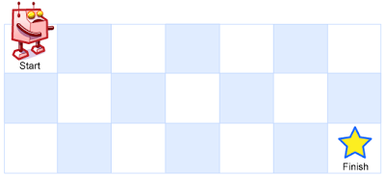

**Input:** m = 3, n = 7

**Output:** 28

**Example 2:**

**Input:** m = 3, n = 2

**Output:** 3

**Explanation:**

From the top-left corner, there are a total of 3 ways to reach the bottom-right corner:

1. Right -> Down -> Down

2. Down -> Down -> Right

3. Down -> Right -> Down

**Example 3:**

**Input:** m = 7, n = 3

**Output:** 28

**Example 4:**

**Input:** m = 3, n = 3

**Output:** 6

**Solution:**

class Solution {

public int uniquePaths(int m, int n) {

int dp[][] = new int[m][n];

for(int i=0; i<dp.length; i++){

dp[i][0] = 1;

}

for(int i=0;i<dp[0].length;i++){

dp[0][i] = 1;

}

for(int i=1; i<dp.length; i++){

for(int j=1;j<dp[i].length;j++){

dp[i][j] = dp[i-1][j] + dp[i][j-1];

}

}

return dp[m-1][n-1];

}

}